


Disclaimer: The content is curated from online/offline resources and used for educational purpose only
Code Repository
LAB MANUAL
Install and Configure Git for Effective Repository Management
Objective:
- To install Git on a Windows system
- To configure Git with a username and email for commit tracking
- To verify successful installation and configuration of Git
Equipment Required:
- A Windows PC or laptop
- Internet connection
- Git installer for Windows (from https://git-scm.com/downloads)
Prerequisites:
- Basic understanding of file systems and folders in Windows
Problem Statement:
As a developer, you need a version control system to manage and track changes in your project files. Git is a powerful distributed version control system used widely in software development. Your task is to install Git on a Windows machine.
Procedure:
Step 1: Download Git for Windows
- Open your browser and go to: https://git-scm.com/downloads
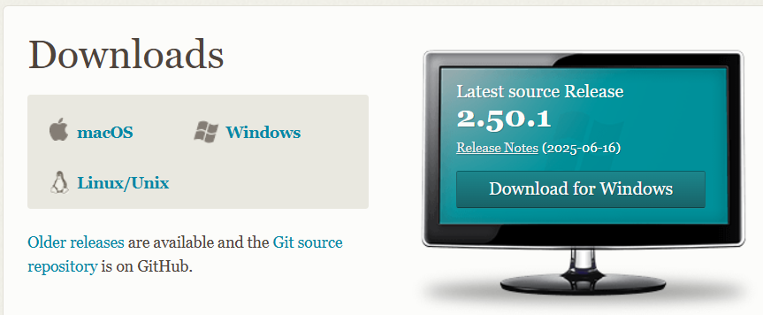
- Click on the Windows download link
- Save the .exe file
Step 2: Install Git
- Double-click the downloaded .exe file
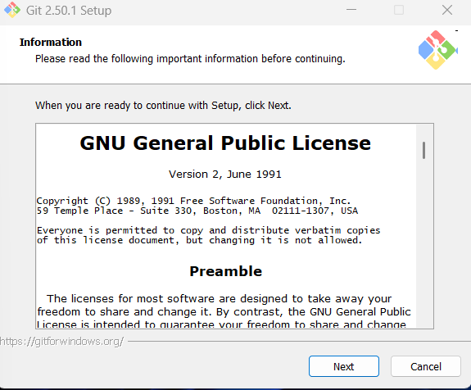
- Click Next through all setup screens. Accept default options unless needed otherwise:
  - Editor: Choose Notepad or leave default
  - Path environment: Select “Git from the command line and also from 3rd-party software”
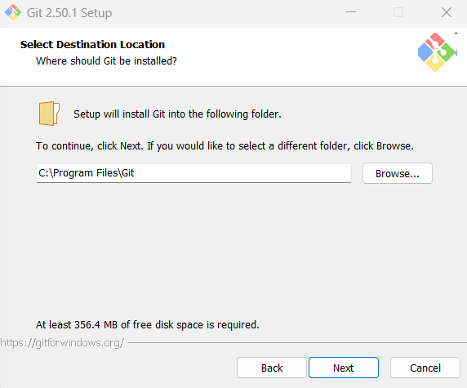
  - Leave other settings as default
- Click Install
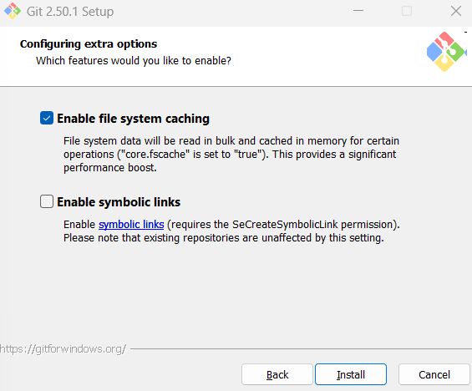
- After installation, click Finish
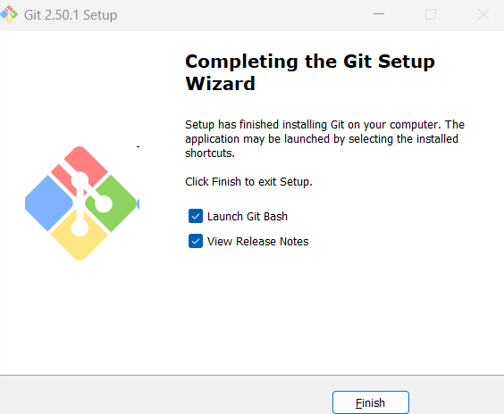
Step 3: Open Git Bash
- Go to Start Menu → Search Git Bash
- Open Git Bash (a terminal window will open)
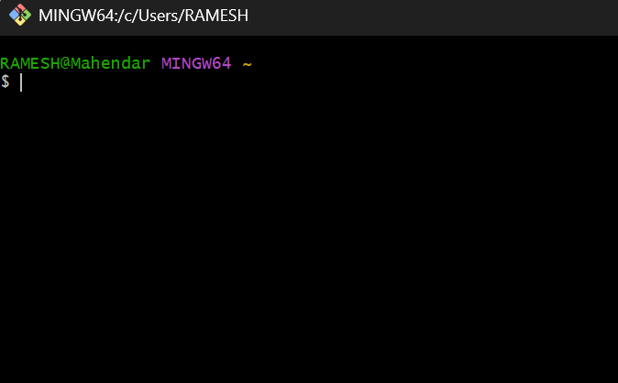
Step 4: Verify Git Installation
- In the Git Bash window, type:
